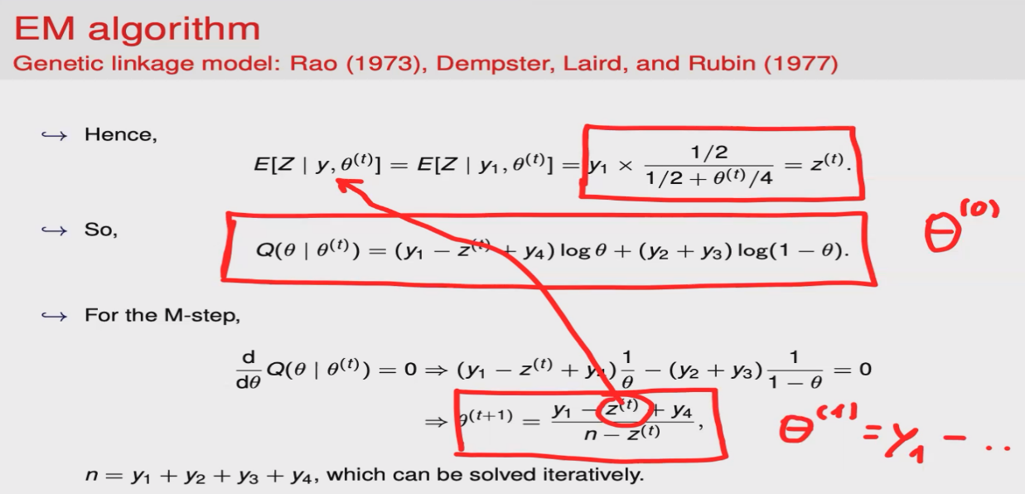
x <- function(theta0, eps){
diff <- 1
theta <- theta0 while(diff > eps){
theta.old <- theta
theta <- 2*theta/(5*theta+1)
diff <- abs(theta - theta.old)
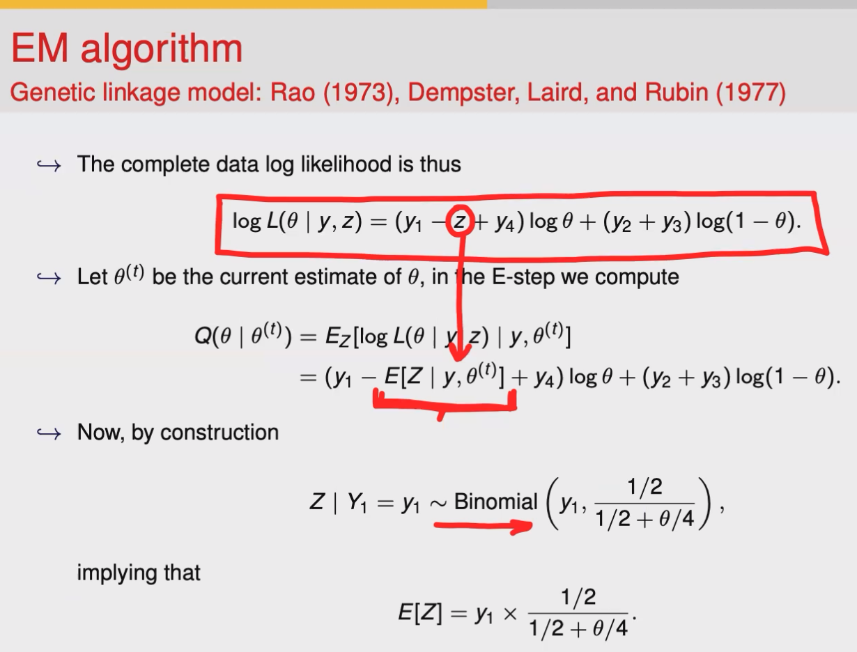
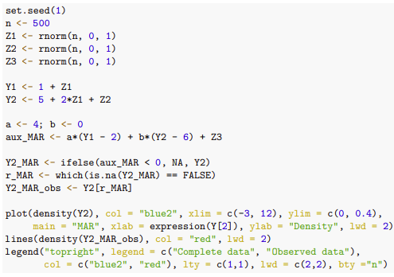
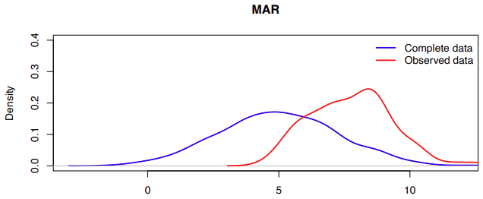
} retur n(theta) }

The observed and complete data
distributions on Y2 are distinct,
which implies that if we were to
use the observed data to make
inferences that depend on Y 2,
those would be biased. In particular, we
see that the mean of the observed data distribution is shifted upwards and the variability of the observed data is reduced compared to that of
the complete data.
(b) For stochastic regression
imputation, the following model will be used to impute the missing values on Y2.
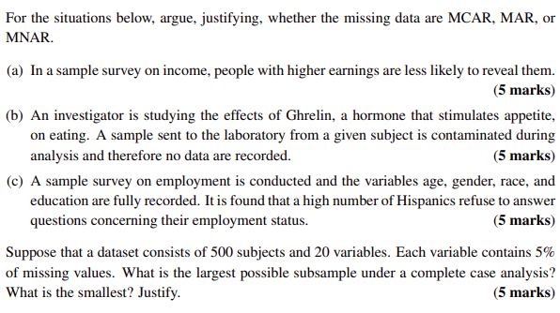
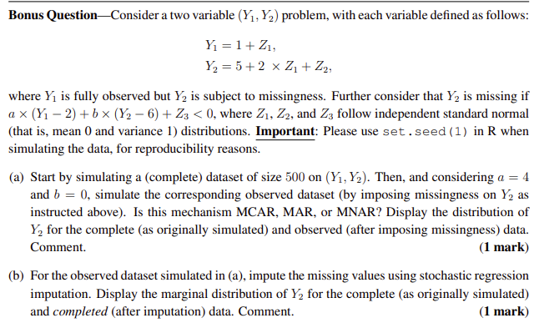
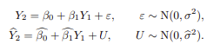
Imply that

